BLOG AND PING
MasterCourse
2006


Table of Contents
Foreword 5
Introduction 6
Just What Is Blogging and Pinging??? 6
Why Is Blogging and Pinging The Newest Marketing Tool? 7
What Do The Spiders See? 9
Simple Steps Lead to Big Results 11
Chapter 1: Creating Your Blog 13
Step1: Go To Blogger.com 13
Step 2: Create an Account 14
Step 3: Naming Your Blog 15
Step 4: Choosing a Template 18
Step 5: Creating a Test Post 19
Chapter 2 – Making Your Blog Settings Count 22
Why Settings Matter 22
Step 1: The Settings Tab 22
Step 2: Settings – Publishing Tab 24
Step 3: Settings – Formatting Tab 26
Step 4: Settings – Comments Tab 27
Step 5: Settings – Archiving Tab 28
Step 6: Settings – Site Feed Tab 29
Step 7: Republish 30
Chapter 3: Creating a Yahoo Account 31
Why A Yahoo Account Is Needed 31
Step 1: Create Your Yahoo ID and Password 32
Step 2: Security, Customization, Verification, and Terms of Service 34
Chapter 4 – Yahoo and Your Blog RSS Feed 36
What Is An RSS Feed? 36
Why Use the Yahoo RSS Feed? 36
Subscribing to Your Blog 37
Chapter 5 – Blog This! 43
What is BlogThis!? 43
Installing BlogThis! 44
Using BlogThis! 45
Chapter 6: Pinging Yahoo 49
Pinging – The Next Step 49
Step 1: Changing the Code 49
Step 2: Creating a Yahoo Ping 52
Chapter 7: Pinging Other Search Engines 54
Creating a Technorati Ping 54
Using Ping-O-Matic 60
How Do You Know If It Is Working? 62
Chapter 8: Using Business Blogs Instead of Websites 65
Blogs Vs. Websites For Small Business 65
Your Business Blog’s Name and URL Matter 66
Finding the Right Key Words 66
Choosing a Title 74
Creating a URL That Works 75
Your Business Blog’s Content 79
Pinging Your Business Blog 85
Chapter 9: Tips and Tricks 86
Tips For Blog and Ping Blogs 86
Tips and Trick for Business Blogs 87
Changes to Your Business Blog Template 88
Change Editor 88
Adding Links 90
Change About Me 92
Changes to Your Business Blog Settings 93
Conclusion 95
Appendix 1 - Blogging Submission Sites 96
Appendix 2 – Weblog Providers 99
Appendix 3 – Photo Blog Software 104

Foreword
This book is just a portion…a TINY portion…of the MASSIVE amount of ‘MOO-LAH” making products you received when you purchased your copy of Seo Cash CowTM. The information presented here is meant to not only educate you, but to make you some SERIOUS MOO-LAH!

Don’t forget, each one of the 7 products you purchased is a COMPLETE BUSINESS, set up and ready to go for you…web page, sales copy, e-book cover, thank-you page… everything you could ever want! PLUS, you got resale rights, master resale rights and private label rights to every one of them…so you can, literally, do anything you want with them!

But, in the spirit of always over-delivering, we didn’t stop there! You also got 8 bonus products worth WELL over $10,000.00…5 of those bonuses have the exact same rights as the products you purchased! That gives you 12 COMPLETE BUSINESSES to slingshot your Internet Marketing career into overdrive. Now, just get out there and do it!

Thank you for your purchase of Seo Cash CowTM, it’s a purchase you’ll always remember as that ONE thing that helped you tremendously on your way to success.
Go out there and grab yourself some MOO-LAH…you deserve it!

Introduction

Just What Is Blogging and Pinging???

No…it’s NOT a new video game! Blogging and Pinging is actually a way to finally get YOU something that you’ve been searching for…a steady flow of good, targeted free visitors to your website. Wouldn’t that make your life simpler? Want to read on?

Let’s start with a definition of a blog.

Blog is short for weblog. A weblog is a journal that is frequently updated and intended for general public consumption. Blogs generally represent the personality of the author or the Web site.

Ok, so what about pinging? Originally, a ping was a program that bounced a request off of another computer/server over a network or the Internet to see if the remote computer was responding. That same program is now used as a method of informing others that your blog exists and also let’s them know when a new post has been made.

When you put the two together – blogging and pinging – you get a technique that is extremely effective at getting ANY web site, no matter how big or small, indexed by the major search engines.

Why Is Blogging and Pinging The Newest Marketing Tool?

Most of you are now saying, “Yea, so?? I can get my site indexed now. What’s the big deal?” The big deal is that blogging and pinging gets your site indexed almost immediately AND it is FREE!!!

If you have any experience trying to get a site indexed and listed in the major search engines, then you know that it is frustrating and very difficult to get done in a reasonable amount of time. After working hard to get your site together, collecting and writing content, worrying about keywords and keyword densities, you are not even close to finished. Now comes the even harder part! Now you have to submit, by hand, your site to all the major search engines. And finally, you get to wait.

That’s right, you have to wait for the spiders to come index your site. This could take weeks or this could take months. There are some methods that will help bring along the spiders a bit faster, but these take lots of time and effort and money. And still, you can’t be sure that the spiders will come fast enough.

Blogging and pinging solves this problem. You can guarantee that spiders will come to your site and that you will get listed in all the major search engines with minimal effort and no money – in about 48 hours!!!

How does it work? The largest search engine, Google, owns Blogger.com. This is the site we will use to help you create your blogs. Google sends their search engine spiders through Blogger.com to find new content.

When you blog the content on your site – an extremely easy process described in Chapter 5 – the URL of the page you are blogging is automatically attached. That way, when Google’s spiders come along, they “see” the URL. If that URL isn’t listed in the Google database, the spiders “run right over” to the URL and check it out!

Imagine that the URL found on the blog is YOUR site! Rather than wait for weeks, months, or even up to a year, you can get YOUR site listed immediately! Google themselves will tell you that they would rather “discover” new URL’s by finding links than get them via submission. So, why not blog and ping and give them what they want!!

Another good piece of news is that once Google has your site, other search engines that use Google’s feed will put you on their site, too. And it all happens at lightening speed!

Another technique you will learn here in Chapter 3 and Chapter 4 is how to get Yahoo to send their news spiders your way. Just like Google, Yahoo is looking for fresh content. And once they pick up your site, so will others.

Finally, Chapter 7 will show you how to ping other services like Technorati and blo.gs. So why would you want to be on these sites? One word: traffic. Services like Technorati spider your links in real time. If you show up on someone’s Technorati link list for their site they’re likely to visit your site to see what you said, increasing your exposure.

What Do The Spiders See?

We’ve talked a lot about spiders and pinging, but just what do spiders see when they come to your site?

Unlike “human” visitors, spiders are looking for links. In fact, they are not looking at your site at all – they are just scanning through your HTML code!

Let’s take a quick look at what a spider sees when it goes to your blog.

Here is a blog about Commodity Investing. As a human visitor, you would see the following:

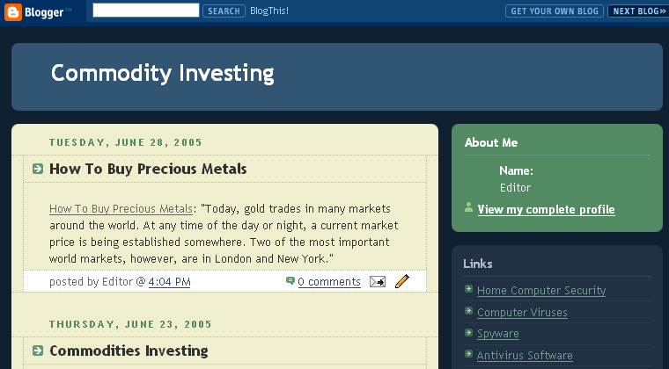

However, the spider is looking below the surface and scanning to find HTML links. When the spider crawls your content, it will see the following:

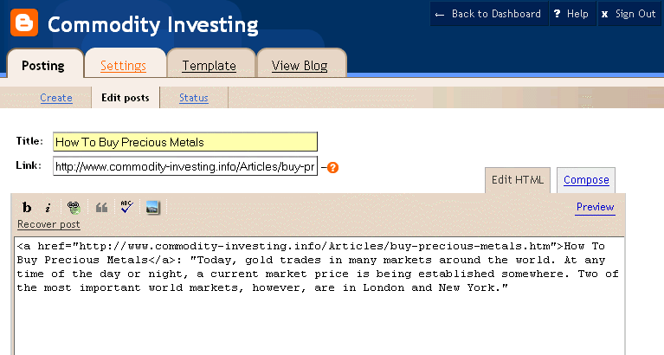
The HTML in the Link field as well as the HTML in the content field will be noted by the spider,

But that is not all! The spider is also looking at the rest of your blog and checking out the HTML in the template:

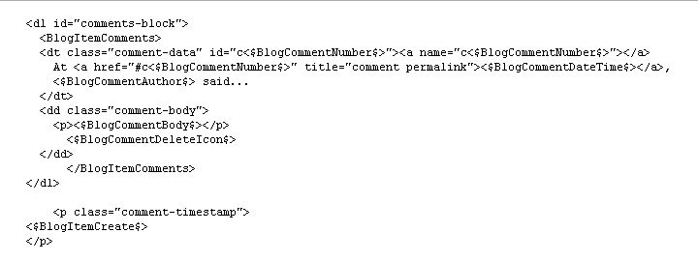

So, keep in mind, that for the blogging and pinging method to work, you have to optimize the blog for spiders. And that is exactly what you are going to learn to do – see like a spider!

Simple Steps Lead to Big Results

As with other marketing strategies, you will need to do some work. However, the steps you will follow to blog and ping are easy and guaranteed to work. Once the system is set up, you can blog and ping to get any of your sites listed quickly.
This ebook will show you how to accomplish each step. The steps will be presented in words and with screen shots. Nothing will be left to chance. And since we’ve done all the research, you will know exactly what to do and when to do it. Keep in mind that you need to do EVERY step and do them in the proper order. If you don’t, then the system simply won’t work.

Now you know why blogging and pinging is an essential tool. So, let’s get started!

Chapter 1: Creating Your Blog
Wipe that worried look off your face! Creating your first Blog is just about as easy as falling off a log…and a LOT more pleasant! This chapter is gonna to take you by the hand and lead you through the 5 easy steps to having your first Blog up and running in no time! So, c’mon, let’s get started.

Step1: Go To Blogger.com

Blogger.com is owned by Google.com. It is a free site that will allow you to create your own blog. In fact, you will have the option of creating as many blogs as you like – all for free.

Put the following URL into your web browser: http://www.blogger.com

When you do, you will see the following screen. From this screen, there are three things you can do. You can sign in (which will be an option once you’ve created an account), you can take a quick tour (which won’t be necessary if you read the remainder of this chapter, although can be helpful to some learning styles), or you can create your own blog now.

Click on the orange arrow that says, “Create Your Blog Now”
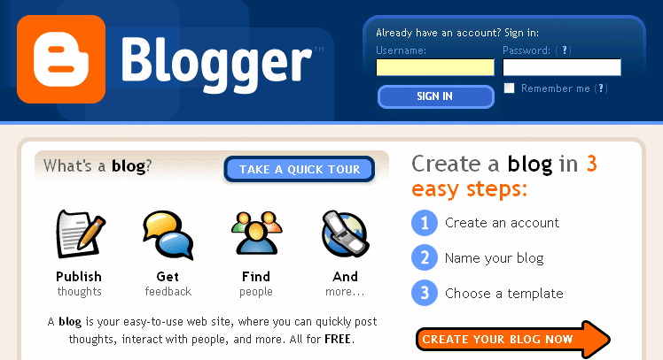

Step 2: Create an Account

For this step, you will need to create a user name and password. It does not matter what user name you choose.

You will also be asked what display name you wish to use. When you post to your blog, this name will be displayed at the end of each post. For now, go ahead and put “editor.” Later, in Chapter 9, you will learn how to change this for each blog if you wish.

Finally, you will need to type in your email address (make sure it is a real address) and check the area that says you agree to their Terms of Service. We have included the Google’s entire Terms of Service in our Appendix.

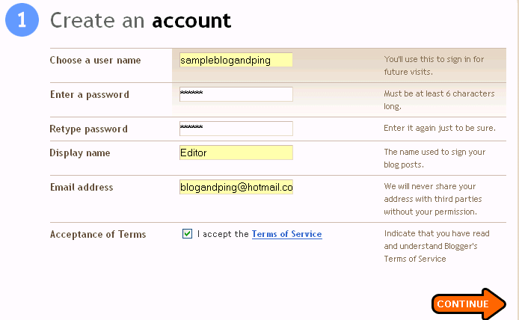

Once you have entered the information, click on the orange “Continue” arrow.

Step 3: Naming Your Blog

Now you will get to name your blog. The first area is the Blog Title of your blog. In this example, the blog title is Kidney Stones. That means, the title at the top of the blog will say Kidney Stones. Later, we will show you how to optimize your Blog Title for search engines. The Blog Title can be changed at any time.

Next you will be asked to create a blog address or URL. Notice that the URL does not have the traditional www at the front. Picking a blog address can be a bit tricky. If you want to keyword optimize your URL for AdSense or other marketing purposes, you will want to read Chapter 8 to find out how to pick a good name.

Before clicking on the orange “Continue” arrow, you will be asked to type in the characters you see in the picture below. This makes sure that you are a person and not an autobot creating the blog.

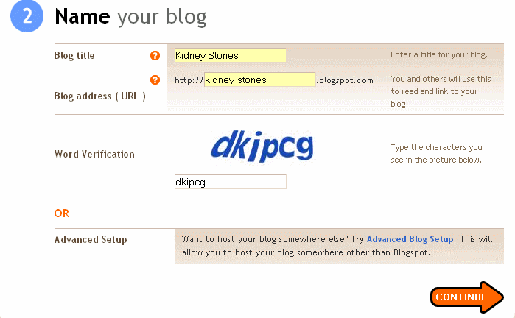

There is one other issue with picking a blog name – the name you want may already be in use. If it is, you will see the following page after clicking continue:

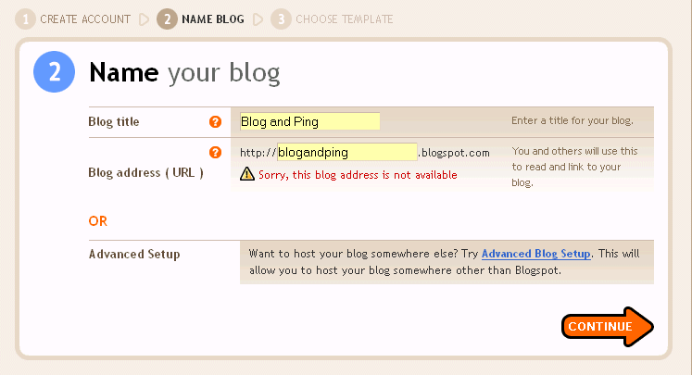

At this point, you simply choose a different blog address.

In the sample above, you might want to try blog-and-ping using the dashes, try reversing the name to pingandblog or ping-and-blog, try bloggingandpinging or blogging-and-pinging, or any other number of variations.

Once you find a URL that is not taken, you can move on to Step 4.

Step 4: Choosing a Template

Blogger currently has 12 ready-made templates to choose from. It really does not matter which template you choose. Each one will allow you to blog and ping. In the following screen shot, “Son of Moto” has been picked.

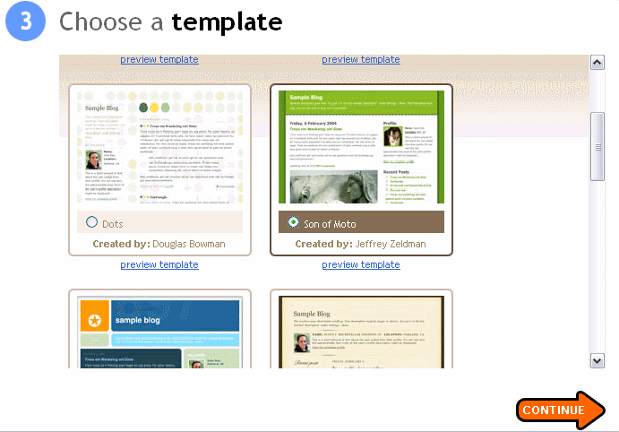

After choosing your template, click on the orange “Continue” arrow. As long as you have followed these steps correctly, you will be taken to a screen that let’s you know that your blog has been created. Simply click on the orange “Start Posting” arrow.
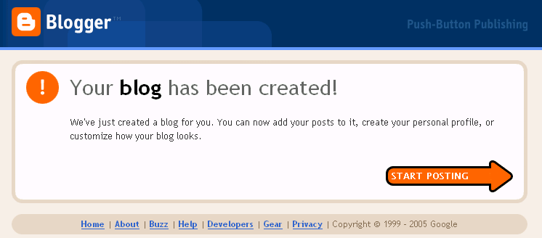

Step 5: Creating a Test Post

In order for the rest of the steps to work properly, you will need to have some content on your blog. Adding content will allow you to create a Yahoo RSS feed in Chapter 4.

The content does not have to be relevant and is easy to add.

- Under “Title” add the word Test.
- There is no need to add anything to the “Link” field.
- In the body of the post, once again, add the word Test.

Then you click on the orange “Publish Post” button.
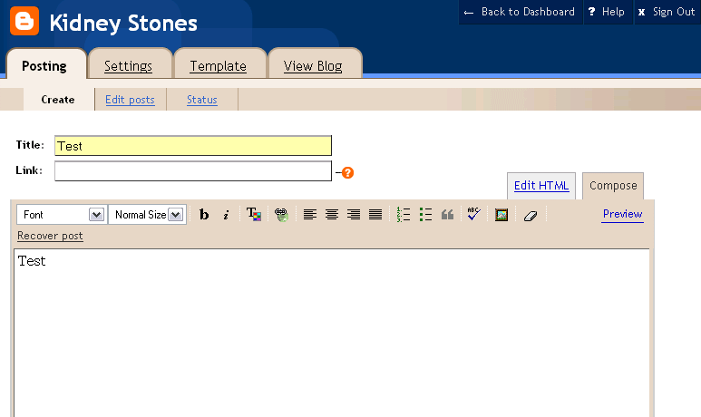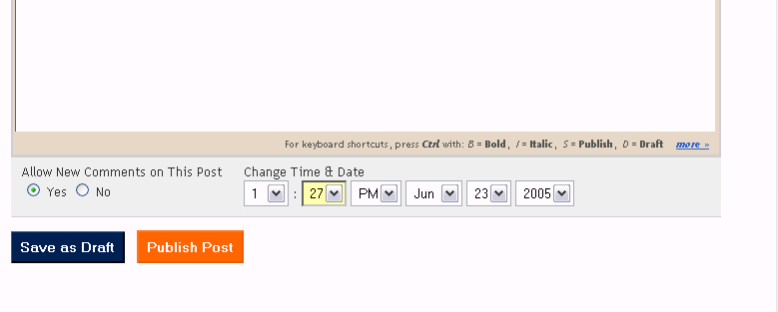

Once you have published the post, you will see a screen that looks like this:
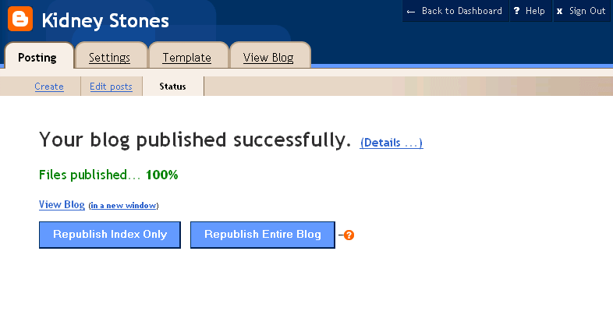
In the example above, if you clicked on “View Blog” you would see that you now have a blog with the URL http://kidney-stones.blogspot.com, a title of Kidney Stones, and one post titled “test.” That is all there is to creating your blog – so let’s move on to the important settings you must know to make this system work

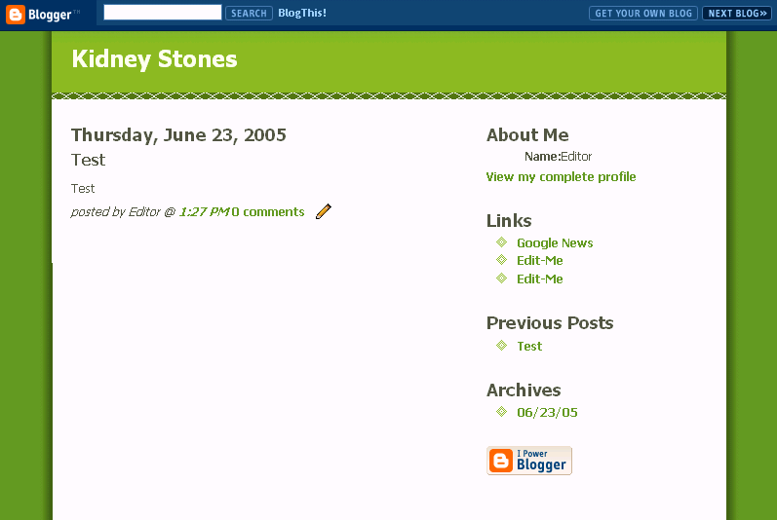.

Chapter 2 – Making Your Blog Settings Count

Why Settings Matter

Up until this point, you could have created your blog without this ebook, even if you aren’t a technical guru. You may have made a few mistakes along the way, but practically speaking, anyone can easily create a blog on Blogger.com.

But, if you were to skip this chapter and try to use the blog and ping method with the standard settings for Blogger.com, you would think that this method of getting spidered did NOT work! And you would be right! The standard settings don’t work!!

More importantly, you would not find the settings needed just anywhere. Determining what worked would be a long and difficult trial and error process. Luckily for you, we have already completed that trial and error process and can tell you exactly what you need to do to make your blogging and pinging successful.

Step 1: The Settings Tab

Let’s look again, at the successful post screen from the last chapter. Under the blog title, you will see 4 tabs labeled Posting, Settings, Template, and View Blog.

If you were in the Posting section, you would also see the same four tabs.

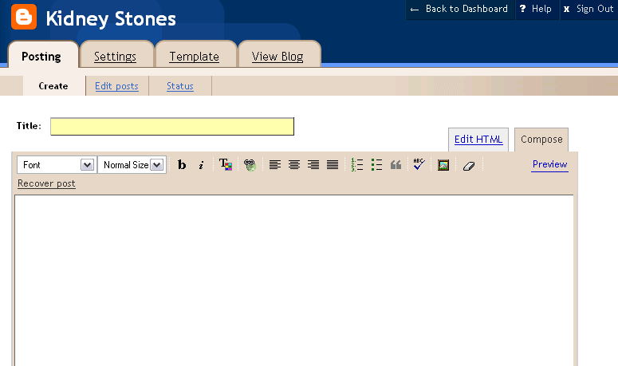

In order to successfully use your new blog for the blog and ping process, you will need to click on and make changes under the “Setting” tab.

Step 2: Settings – Publishing Tab

Once you have clicked the “Settings” tab, you will see settings has 8 sub-tabs. We will only be concerned with 5 of them.

The “Basic” tabs settings are correct. You do not need to make any changes for the blog and ping method to be successful.

Click on the “Publishing” tab. Google automatically shows your BlogSpot address. You will want to save this address to your notepad for future use.

The other piece of information on this page needs to be changed to “Yes.” You definitely want Weblogs.com to be notified whenever you make changes to your blog.

Once you have copied down your URL and made the change to this page, click on the orange “Save Settings”

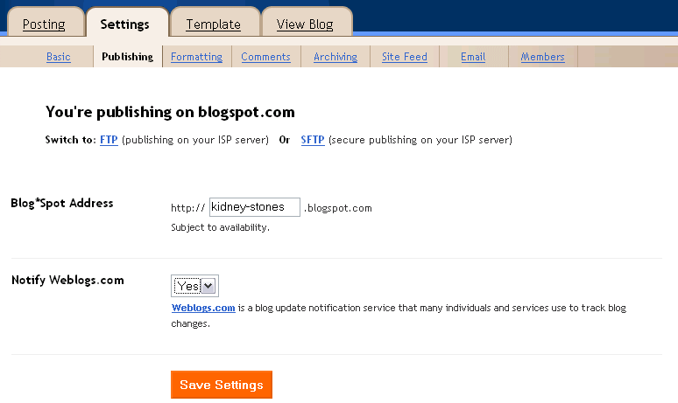

When you do, you will see this page again with the following header at the top:



There is no need to “Republish” your blog at this time. You will republish your blog after you have made all the changes.

Step 3: Settings – Formatting Tab

Now click on the “Formatting” tab to make one change. Towards the bottom is a field called “Show Link Field.” Change that to yes and Save the Settings.

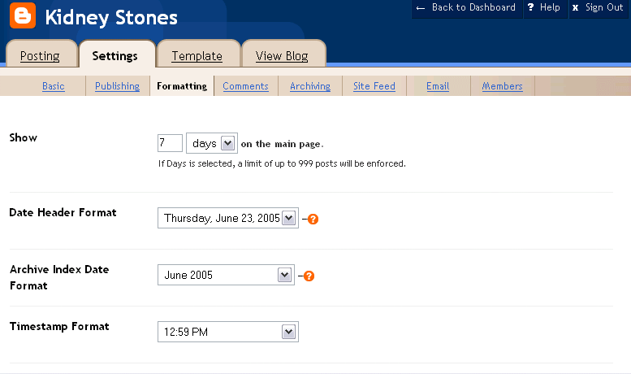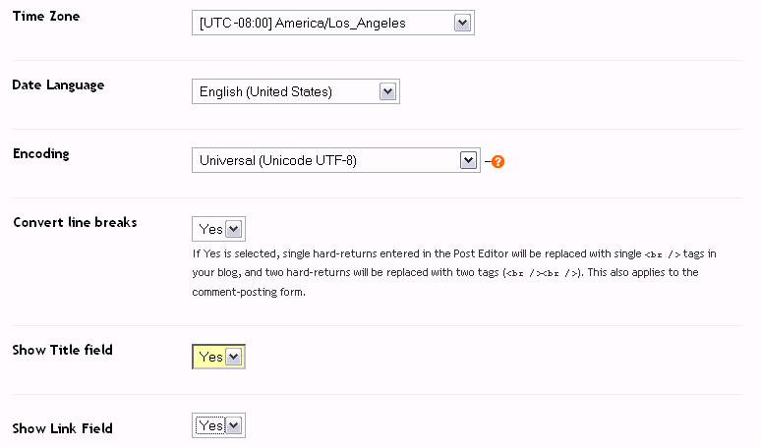
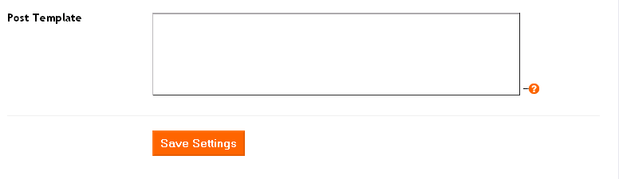

Step 4: Settings – Comments Tab

This is one step that you can use but do not have to use. Although it doesn’t always happen, if anyone posts a comment to your site, the spiders will see that comment as fresh content.

To allow posts to your blog you will need to make a few changes.

- “Who Can Comment” needs to be changed to anyone.
- “Comment Notification Address” needs to have an email address where you can receive notices that someone has posted a comment to your blog.

Now click on the orange “Save Settings” button.

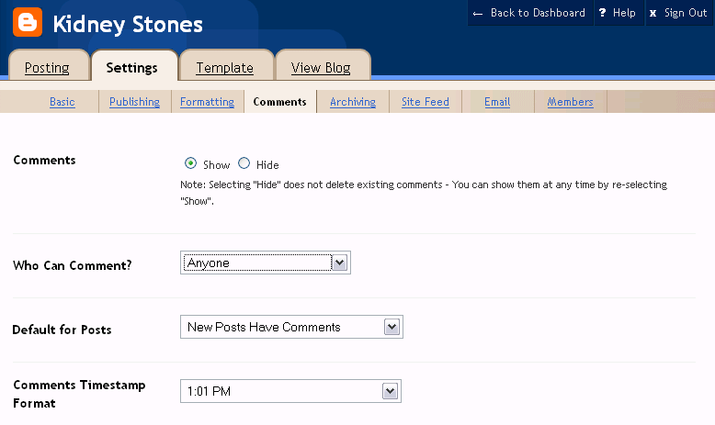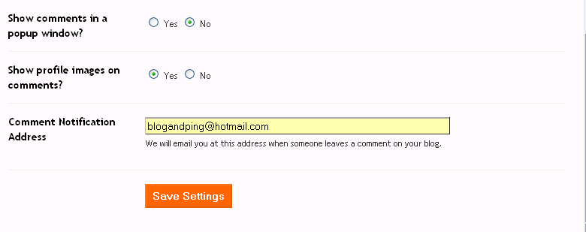

Step 5: Settings – Archiving Tab

You want your blog to be archived daily. Make this change and click on the orange “Save Settings” button.
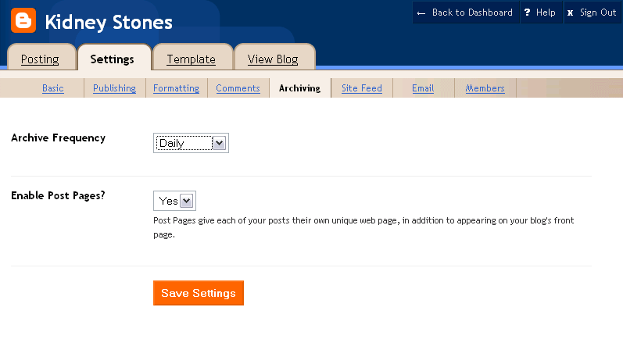

Step 6: Settings – Site Feed Tab

All the settings in this tab are correct. However, you will need to copy the “Site Feed URL” to your notebook for future use. Click on the orange “Save Settings” button.

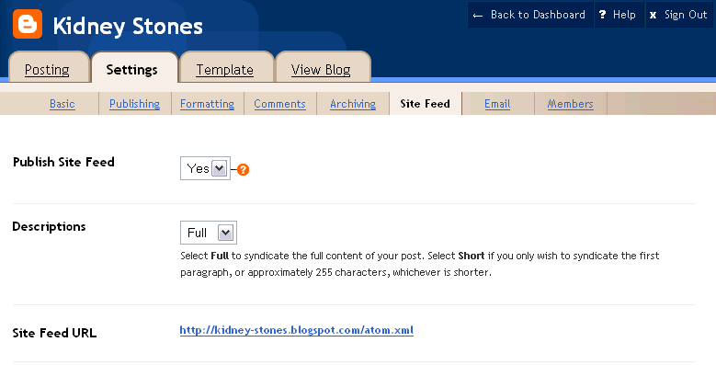

Step 7: Republish

Once you have saved the settings under the “Site Feed” tab, it is time to republish your blog. You will want to click on the dark blue “Republish” button.

When you do, you will get the following screen:

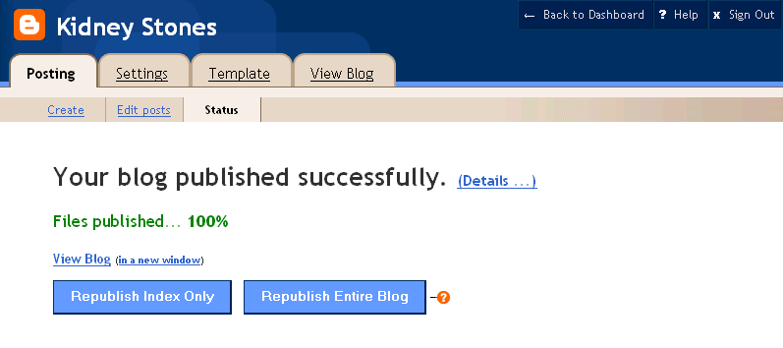

Now you have a blog that is set up for the blog and ping process. The next step is to create a Yahoo account!

Chapter 3: Creating a Yahoo Account

Why A Yahoo Account Is Needed

In the introduction, we told you that Google owns Blogger.com and sends its spiders through Blogger looking for fresh content. We also told you that there was a way to get Yahoo looking at your blog, too. In order to get Yahoo spidering your blog, you will need a yahoo account.

Go to http://www.yahoo.com. You will see the following screen. Click on “My Yahoo!” found to the right of the title:

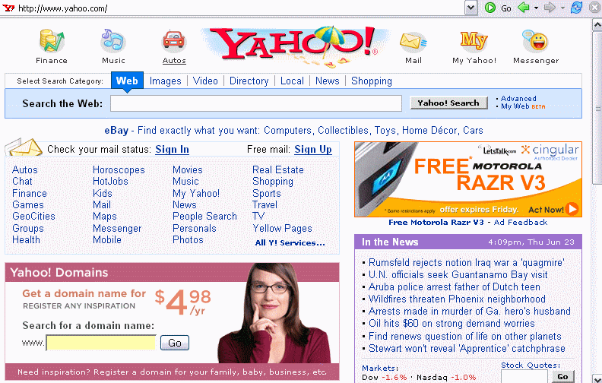
Next, click on “Sign Up” found near the top of the screen:

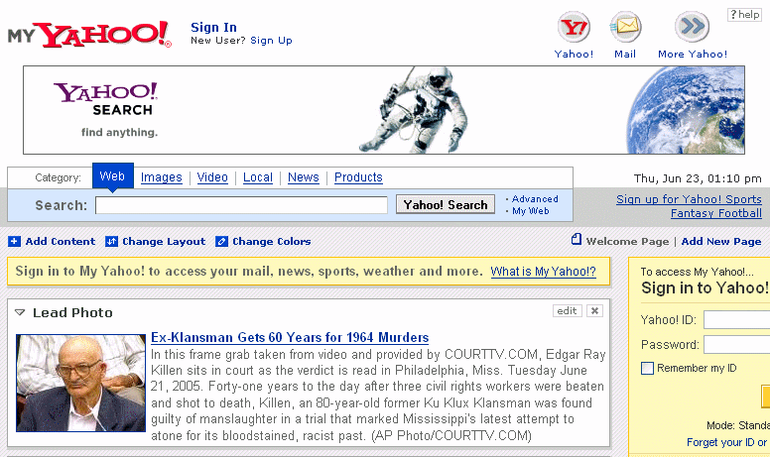

Step 1: Create Your Yahoo ID and Password

When you click on “Sign Up”, you will be taken to a page that requires quite a bit of information. The first section is “Create Your Yahoo ID.”

Here you will need to enter your first name and your last name. Then you will have to choose your preferred continent and your gender.

Now it is time to choose your Yahoo ID, which will also be your Yahoo email.
Please note that your Yahoo ID may contain only letters, numbers, and the underscore. No dashes or other punctuation may be used.

Once you have chosen your Yahoo ID, you can press the “Check the Availability of This ID” button. As with Blogger, the name you want may not be available. If not, then simply choose another. If it is, go on to the next field.

Next you will need to create a password. The password needs to be at least 6 characters and IS case sensitive. Once you have chosen a password, you will need to retype it.

Be sure to check the box “Create my free Yahoo! email address.

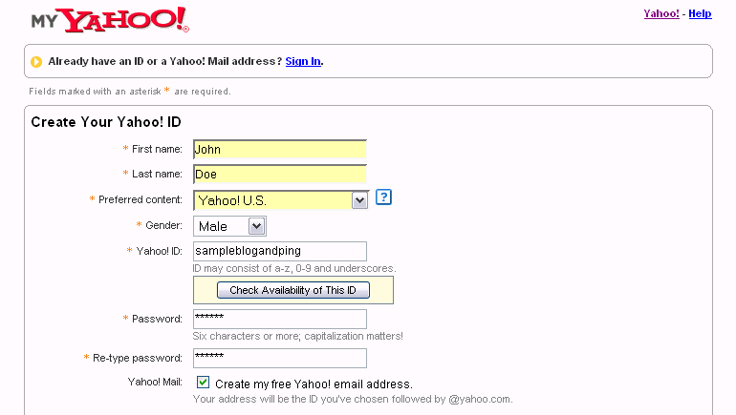

Step 2: Security, Customization, Verification, and Terms of Service

You will need to select a security question, give your birth date and your ZIP code. This way, if you were to forget your password, Yahoo! would ask you to answer the questions so that they could let you back into your account. Be sure to tell the truth or you will forget the answers to the security question!

There is no need to customize your account. You can simply leave this section as it is.

Then you will need to verify your registration. Once again, you will type in the numbers and letters you see. In this way, Yahoo! keeps automated registrations from occurring.

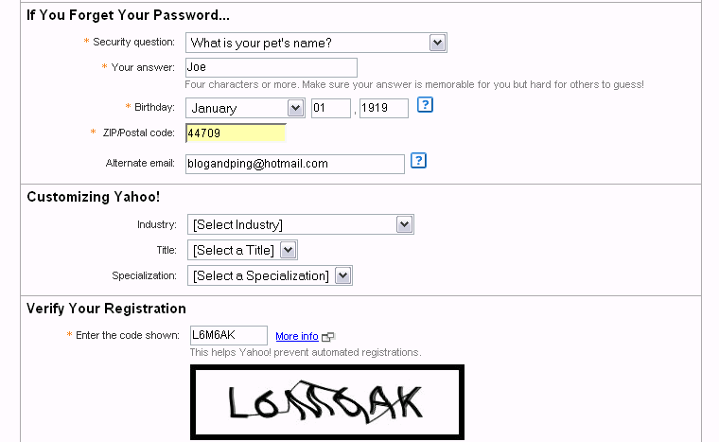
Finally, you will be asked to read and agree to the Terms of Service. We have placed Yahoo’s Terms of Service in the Appendix for your convenience.

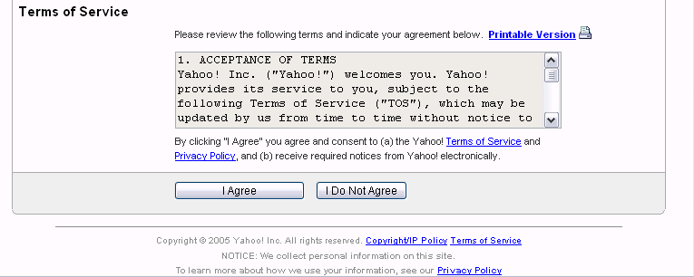

Once you click on “I Agree.”. Now it is time to link your Blog to your Yahoo account!

Chapter 4 – Yahoo and Your Blog RSS Feed

What Is An RSS Feed?

How and why RSS works is rather technical, but that shouldn’t worry you at all because you don’t need to know the technical side to get it to work for you. Short for RDF Site Summary or Rich Site Summary, RSS is an XML format for sharing of content among different Web sites.

A Web site that wants to allow other sites to publish some of its content creates an RSS document and registers the document with an RSS publisher. Luckily for you, blogs have this built right into their system. That means that your content can be seen by people who subscribe to RSS readers like Bloglines, Yahoo, or MSN. And this is what gets your website noticed and indexed by major search engines.

Why Use the Yahoo RSS Feed?

You will want to create a MyYahoo account because Yahoo allows you to subscribe to your OWN blog RSS feed. This means that you can get Yahoo’s spiders looking at your blog immediately. All you have to do is subscribe to your own blog and Yahoo will visit and index your blog for free!

Subscribing to Your Blog

After you have registered for your free MyYahoo! account, you will come to the following page:
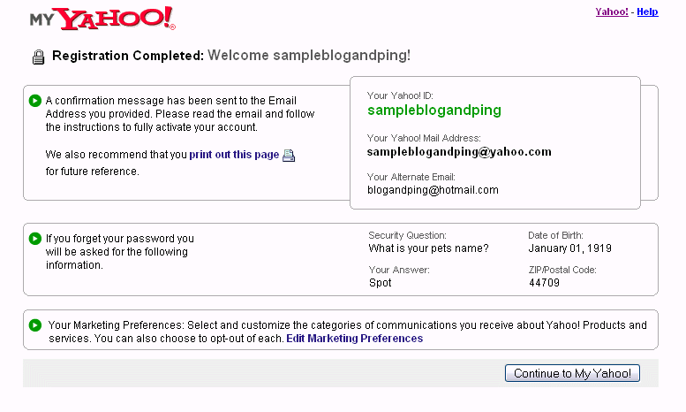

You may want to print/screen capture this page for your records. Once you have this information saved, press on the “Continue to My Yahoo!” button.

This will take you to your own personal Yahoo landing page. You can personalize this page in any way you choose. For the purposes of blogging and pinging, you do not need to worry about anything except signing up for your blogs.

To register for your blog, the first thing you have to do is click the “Add Content” button at the bottom of the landing page.

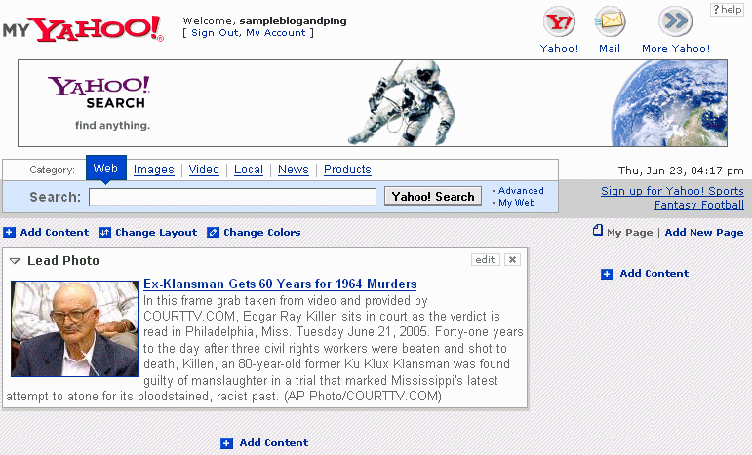

Doing so brings you to a page that allows you to add content in various ways. You will see a large, blue “Find Content” field. Next to the “Find” button, you will see a link called “Add RSS by URL. Click on this link so that you will be able to add your blog’s Site Feed URL.

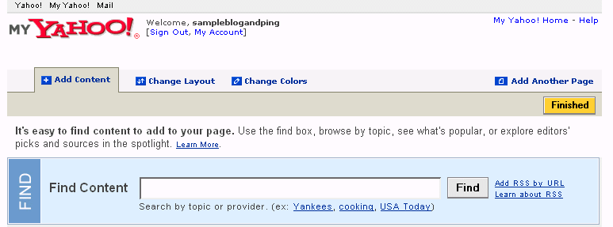
WARNING: This is not your blog’s URL but the SITE FEED URL. Your site feed URL will have atom.xml at the end. If you place the wrong URL in this field, the system will not work. In Chapter 2, Step 6, you were told how to find your site feed URL.

In the following example, the BLOG URL is http://kidney-stones.blogspot.com and the SITE FEED URL is http://kidney-stones.blogspot.com/atom.xml.

Once you have added your site feed URL, click on the “add” button.

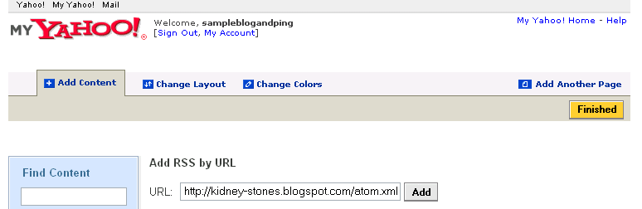

Yahoo then does a quick search to see if there really is a blog with this RSS URL. Remember earlier when you had to create a test post (Chapter 1, Step 5)? That test post allows your blog to be “active” so that when Yahoo does this search they will find your blog. You will get a screen that looks like the following:

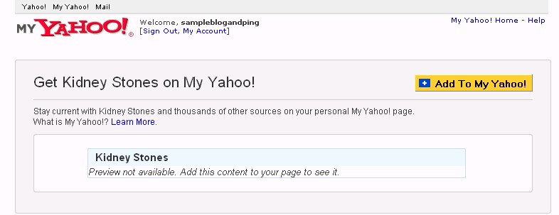

Now you will need to click on the “Add To My Yahoo!” button. You should then see a page like the following:

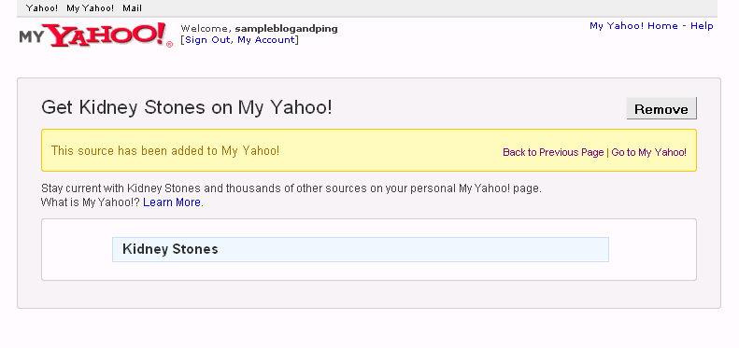

If you put in the wrong URL or have not created a test post, you will see the following screen:

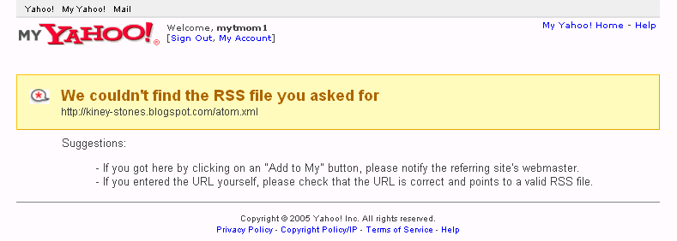

(Look closely and you will see that the site feed URL is not correct because the spelling of the word kidney is incorrect.)

Once you have your site feed URL accepted, click on the “MyYahoo! Home” link. When you scroll to the bottom of your Yahoo page, you will now see that Kidney Stones is listed.

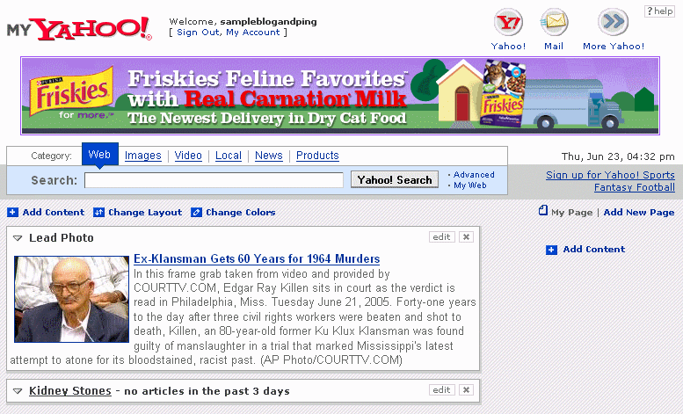
Let’s review quickly. You now have:

- A Blogger account and at least one blog.
- A MyYahoo account
- MyYahoo RSS feed link to your blog

Now comes the fun part. It is time to start adding content to your blog! Chapter 5 will show you how!

Chapter 5 – Blog This!

What is BlogThis!?

Earlier, you learned how to create a very simple post. Let’s look again at that page as a refresher:

First you put in the title and then you added the body. In order for blog and ping to work, you will also need to add a link. If you had to do this all by hand, it would take some time, but Blogger.com has made this fast and easy with the “BlogThis!” tool.
With BlogThis! you can easily make a blog post without ever having to visit Blogger.com.

BlogThis! creates your title, adds your link, and adds any highlighted content. If you wish to add more content, you can do so. Then, with a couple of simple clicks, you have a new post on your blog. It is as easy as that!

Installing BlogThis!

There are two ways to use BlogThis!: if you use Windows and Internet Explorer, you can use BlogThis! straight from the Google Toolbar. You can install Google Toolbar by going to http://toolbar.google.com/index_2.

If you're on another browser, just drag the link below to your browser's Link bar.
http://help.blogger.com/bin/answer.py?answer=152&query=

Once you have BlogThis! installed, try clicking on the icon. You will get a small screen that looks like this:

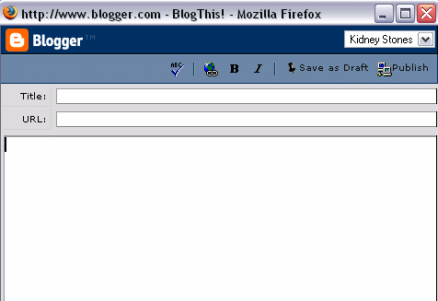

The upper right hand corner has a listing of each one of your blogs. When you use BlogThis! correctly, all of the fields will be filled in automatically.

Using BlogThis!

Using BlogThis! is as easy as installing it!

The first thing you need to do is go to the website you wish to get indexed. In this example, I am wanting to index my website about commodities investing and will be using my commodities investing blog as a way to do this quickly.

Ideally, your website will have many different pages. For many of you, you have been creating pages using Traffic Equalizer or Traffic Generator. The key here is to blog from different pages each time.

Go to one of your pages and highlight an area of text. You do this by running the mouse over the text with the left mouse button held down.

For the typical blog and ping method, your blog will only be visited by spiders and not by real people, so the text you highlight is not important. (For those that want to use their blog as a website or other business tool as well, you will want to read Chapter 8 to learn how to make your blog acceptable for people and not just bots.)


Next, just click on the BlogThis! link that is either in your Google toolbar or that you added earlier.

You will see that a title has been placed in the title field and a URL has been placed in the URL field. Additionally, you will see the text that had been highlighted in the website is now in the body of the blog. You will also see a URL link in the body text.

Having links in both the URL field and the body will help you get indexed more quickly.

Now you have to determine which blog you are adding content to. In this case, the material is for the Commodity Investing blog, so you would click on the expand arrow and then click on Commodity Investing. BlogThis! will refresh quickly and then you post by clicking on the Publish button in the upper right hand corner.

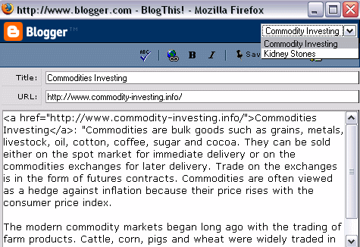
You will then see a “Done” page that shows which blog you have posted to. Now that you have fresh content, it is time to ping!



Chapter 6: Pinging Yahoo

Pinging – The Next Step

Search engines love changing content and therefore WANT to visit a site when it is updated. Blogs are a great way of offering this changing content, especially since they have a “pinging” feature.

In Chapter 2, Step 2, you set up your blog to automatically notify Weblogs.com of any changes. This means that each time you change your blog, a message is sent out for search engines to come and visit.

In addition to letting Weblogs do the work, there are a few other things you can do to create more “interest” in your blog. One of them is to Ping Yahoo.

Step 1: Changing the Code

The first thing you need to do is to go to the blog you want to ping and then add it to your bookmarks or favorites.

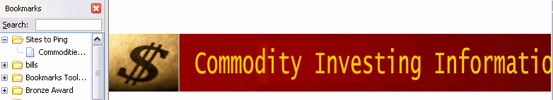

Once it is in your favorites or bookmarks, open the list and right click on the blog name. For instance, in the example here, I saved Commodities Investing in my bookmarks. Then I right click on Commodities Investing in the list.

This will bring up a list of different actions. At the bottom of the list is “properties.” Left click on properties and you will see the following screen:

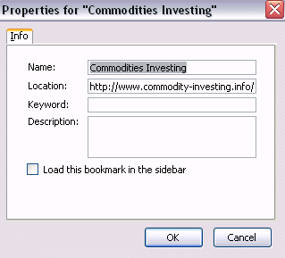

Now, if you were to “ping” with the properties as they are, the blogging/pinging would not be effective. This is one of the “secret” steps that took a long time to figure out. For the blogging and pinging to work effectively, you are going to have to change the location field.

Currently, the location field has your URL. You need to add a string of text BEFORE this URL. Here is the string of text that you need to add:

http://api.my.yahoo.com/rss/ping?u=

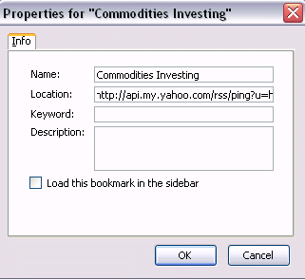

So in the case of the example above, the old location was http://www.commodity-investing.info. The new location is:

http://api.my.yahoo.com/rss/ping?u=http://www.commodity-investing.info.

Let’s take another example because this is VERY important to get correct. If your location URL is currently: http://name-of-blog.blogspot.com, the new location will be http://api.my.yahoo.com/rss/ping?u=http://name-of-blog.blogspot.com.

Step 2: Creating a Yahoo Ping

Now that you have the location correct, it is time to ping Yahoo. To do this, you just click on the bookmarked or favorites link.

If the ping worked correctly, you will see a page like the following:



It shows that a ping was sent out to http://www.commodity-investing.info. If you had pinged the kidney stones site, it would say Refresh requested: http://kidney-stones.blogspot.com. The ping message will not show the new location code but the ACTUAL URL for the blog you have pinged.

To prove that Yahoo pinged the blog, you can go back to your Yahoo home page. Go down to the bottom of the page where you registered your blog earlier. You should see the latest post under the blog.

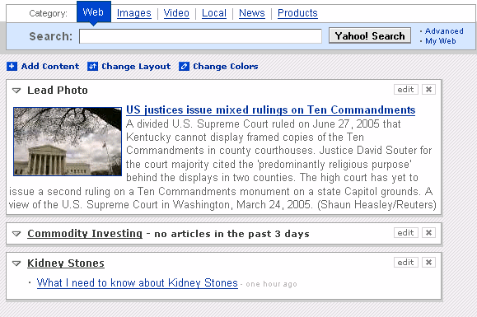

Now both Weblogs.com and Yahoo have received info that your blog has new, updated information. Let’s look at ways to get other search engines aware of your fresh content.

Chapter 7: Pinging Other Search Engines

Creating a Technorati Ping

There are a number of services designed specifically for tracking blogs. By sending a small ping to each service you let them know you’ve updated so they can come check you out.

One such service is Technorati. Technorati is a real-time search engine that keeps track of what is going on in the world of blogs. Technorati automatically receives notification from blogs as soon as they are updated. This means that it can track the thousands of updates per hour that occur. To get your blog listed on Technorati, go to http://www.technorati.com/.

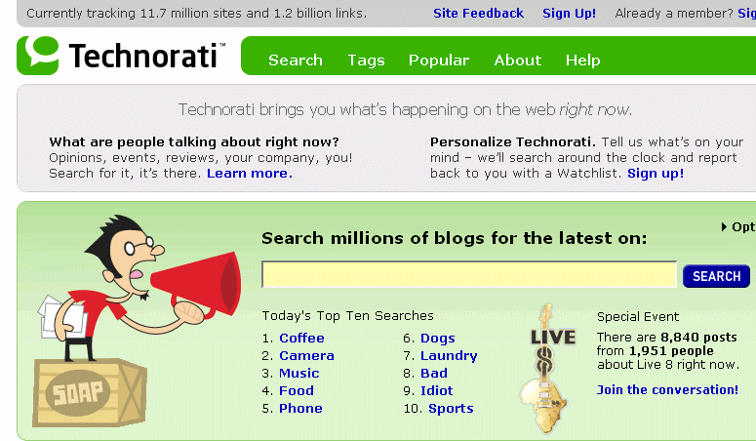
At the top of the site, you will see a “Sign Up” link. Clicking on that link will bring you to the following page:

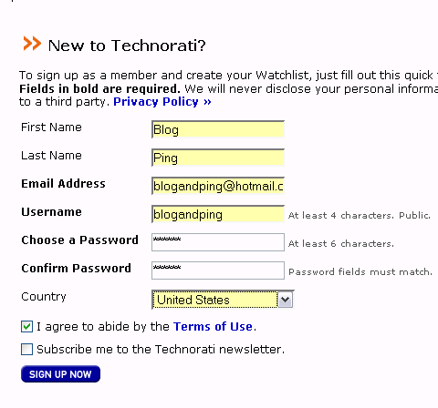

Fill in the First Name, Last Name, Email Address, Username, Choose a Password, and Confirm a Password fields. Then you will need to select your country and agree to the Terms of Use. (A copy of Technorati’s Terms of Use are available in the Appendix of this ebook.)

Click on “Sign Up Now” and you will be brought to Your Account page.

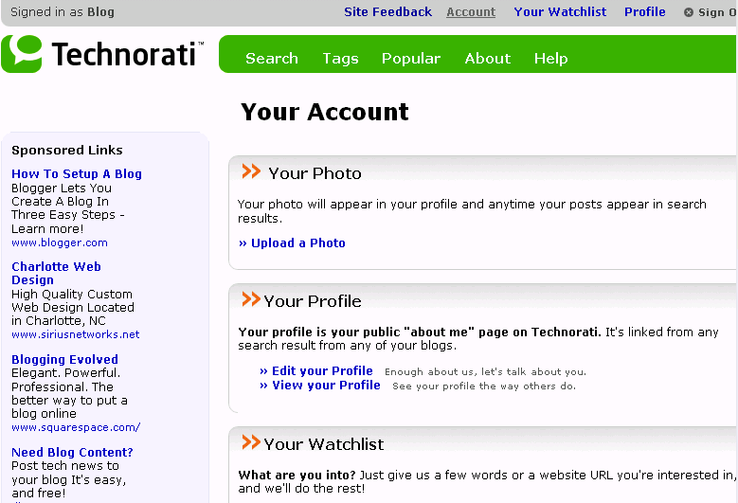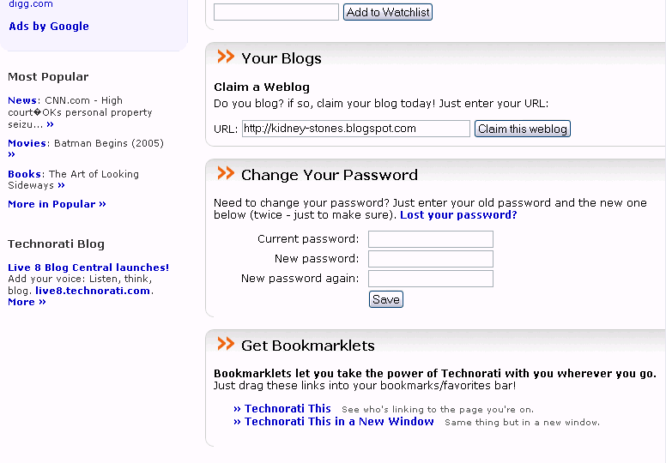
Scan down the page until you get to the “Your Blogs” section. Now, add your blog’s URL. Please note that this is not the LOCATION code from the Yahoo ping, nor is it the RSS feed URL. This is your blog’s actual URL.

Once you have added the URL, click on the “Claim this weblog” button. The final step is actually “claiming” your blog. The easiest way to do this is to follow the “Profile Link” method shown at the bottom of the page.

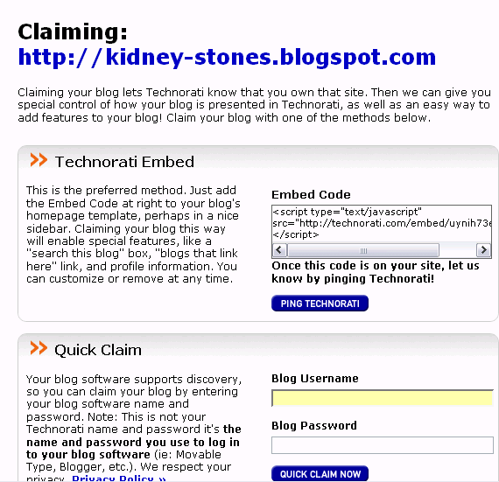
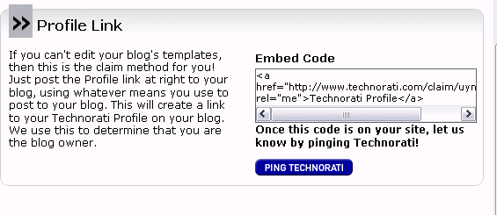

Highlight the code found in the “Profile Link” box. Now, go to your blog and create a post. Put the code into the body of the post. You do not need to worry about adding a title or adding a link. Publish the new post.

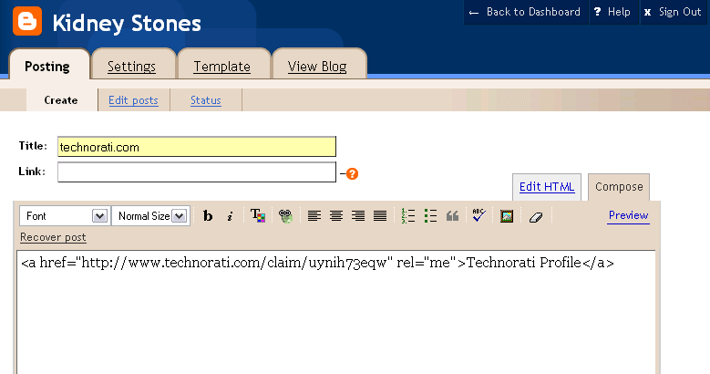

Now click the “PING TECHNORATI” button in the “Profile Link” method. You will receive this message:

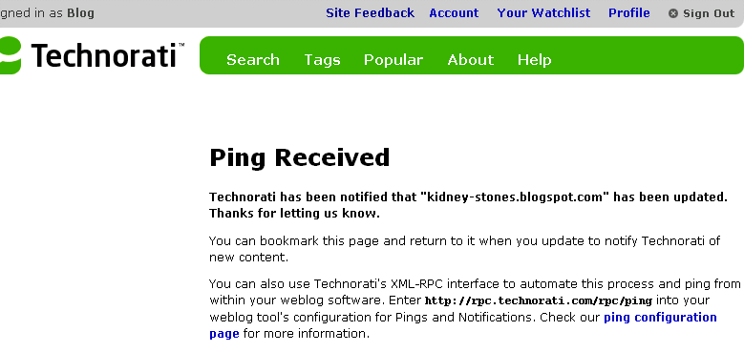

Although this is not difficult, it can be time consuming.

Imagine that you have several new blogs and you have to follow this routine for each one of them.

Additionally, Technorati is not the ONLY blog search engine out there so you would have to repeat a similar process several times for each blog. Keeping track of all those and hitting each one whenever you update would be a hassle. OR you can use a site like Ping-O-Matic.

Using Ping-O-Matic

Ping-O-Matic is a service that let’s you ping Technorati, and several other search engines!! These search engines include:

- Weblogs.com (not really necessary since you will be using Blogger.com and they automatically ping weblogs)
- Feed Burner
- Feedster
- Blogdigger
- Moreover
- Blo.gs
- Syndic8
- My Yahoo! (Not necessary because you will be pinging My Yahoo on your own. Although you can rely on Ping-o-Matic to do this for you, pinging Yahoo by yourself is a faster and better process.)
- Blogrolling
- Weblogalot
- Technorati
- NewsGator
- PubSub.com
- Blogstreet

Go to http://www.pingomatic.com.

You will need to fill out two fields – the Blog Name and the Blog Home Page. Once again, the URL needed is the actual URL and not the RSS or Location URL. Then click on “Submit Pings.”

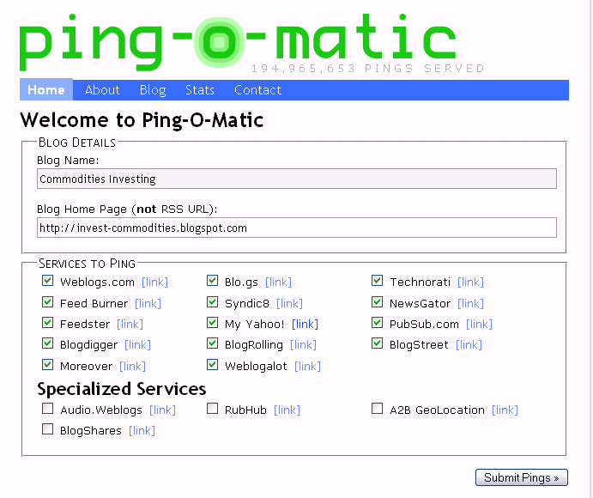

Now your blog has been submitted to each one of these blog search engines. Simply bookmark the page and then each time you update your blog, you can have Ping-o-Matic let everyone know.

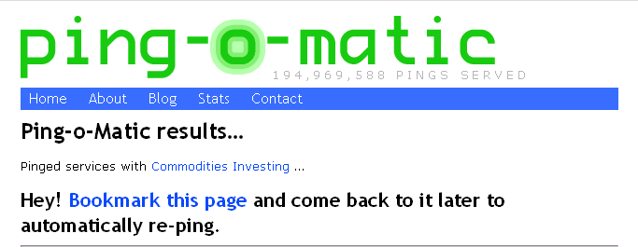

How Do You Know If It Is Working?

The purpose of the blogging and pinging, as we have been doing it, is not to get your blog spidered, but to get your website spidered. So, before you really get started, I want you to go to http://www.google.com.

In the field, put the following information:

allinurl:+yourwebsite.com

If your site has not yet been spidered, you will get a message that there were no results.
Wait about 48 hours after creating your blog and starting the blog and ping process and put the same code into the Google field. Now you should see something like this:

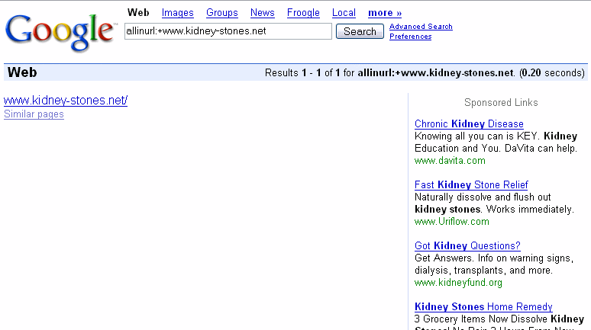

Instead of nothing being found, Google has found one page.

Try this again in a few more days, and you are likely to see something like this:



That’s right, 4990 pages have been spidered! And in under a week!

Chapter 8: Using Business Blogs Instead of Websites

Blogs Vs. Websites For Small Business

Up to now, we’ve been assuming that you are using your blog to get one of your web sites spidered. Another way to use the blog and ping method is to try to get your blog spidered in its own right!

Why are blogs better than the traditional website? You have the ability to communicate one-on-one with customers in a casual way, and you can respond to timely events and maintain that community interaction on a weekly, or even daily basis. Plus:

- Each blog entry is shown in chronological order on a blog’s homepage but, each entry is in reality its own web page, with its own unique URL and title. So, an active blogger can create hundreds of keyword rich web pages in a matter of months.
- The typical small business web site is lucky to receive an update several times a year. Search engines like change. So, if you change your blog several times a week, you will constantly be updated in the search engines.
- Links from other high quality blogs will send traffic and get your blog and web site noticed.

Regardless of the type of business or the goals of the site, it's clear that with little investment small business blogging brings big returns. It's a great tool for any business.

Your Business Blog’s Name and URL Matter

If you are blogging and pinging to get a website spidered, the name and address you choose for your blog is not terribly important. However, if you are using your blog as your main site, the name definitely matters – A LOT!

You will want to use keywords for both your title and your address. In fact, here is a little tip: you may eventually want to add Google AdSense to your site so it is better to pick a name that will place the right ads on your site.

Finding the Right Key Words
In order to use keywords for your title and URL, you have to know what they are. Effective keyword research for blogs requires knowing your audience.

Before starting to develop the blog, you need to ask yourself the following questions:

- Who do I expect to read my blog?
- What do I expect them to get from it?
- What are myr audience's "hot-button" keywords?

Answering these questions will help you create your keyword list. In fact, the answer to the last question will certainly provide a few keywords. Finding others is easier than you think. We will discuss two different tools in this section.

The first is Results Generator. Results Generator lets you know what words are being searched for on Overture.com. Start by going to http://www.resultsgenerator.com/overture/. You will see the following screen:

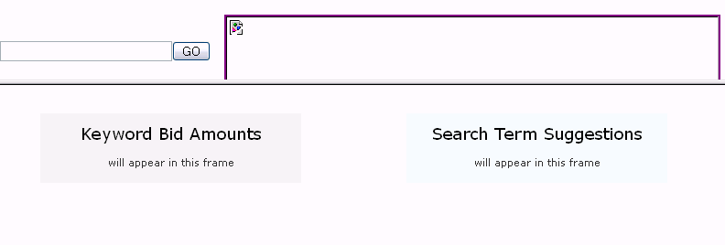

Next, put your main topic in the GO field and click on GO. In the example, I am looking for key words that have to do with the kidney stone blog.

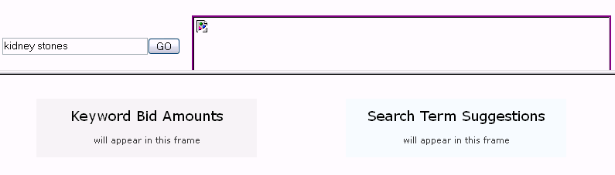

The left column will show you how much people are paying for different words on Overture.com. Although interesting, this is not as important as what you will find in the right hand column. Here you will see all the related searches done in the past month and the exact words used for that search.
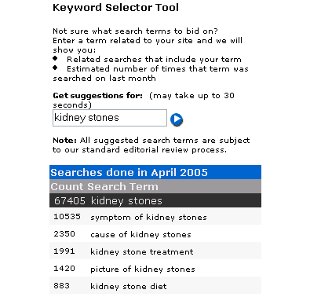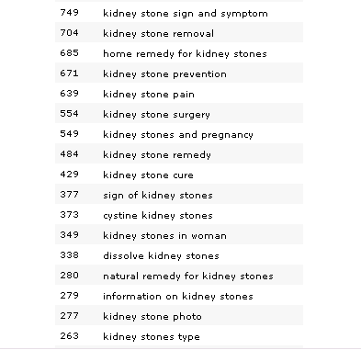

This list is a great keyword list.
The second way to find keywords is using WordTracker found at http://www.wordtracker.com/.

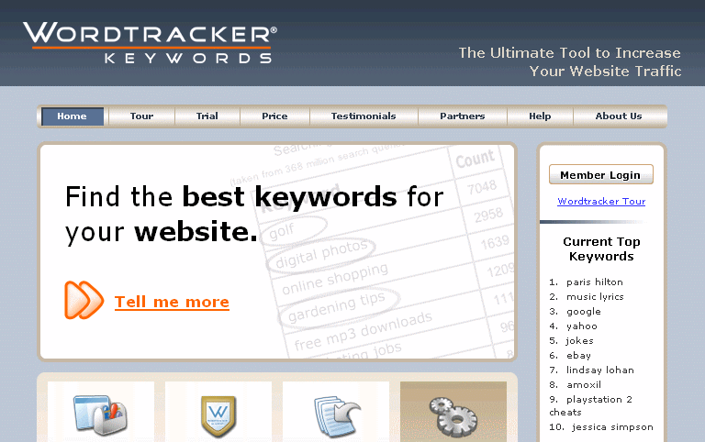

When you access this page, you will want to click on the “Trial” tab at the top of the page. The trial works just like the paid version but does not give you nearly the number of words. However, to get a small keyword list started, the trial is quite valuable.

To get the free trial, you need to put in your name and your email address and then click on “Start the Trial.”
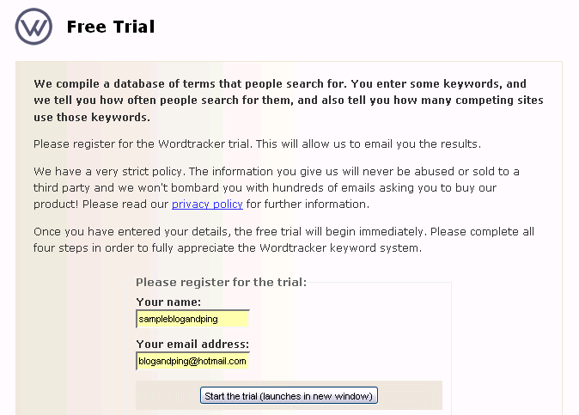

This brings you to a welcome page and again, you have to click on the Start the Trial arrow.

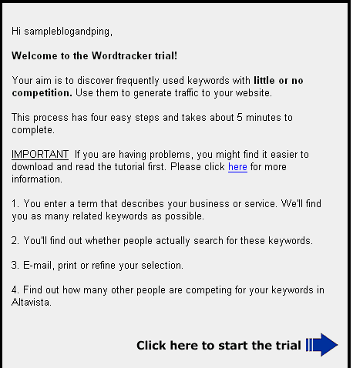
That brings you to Step 1. Add your topic to the field and click on proceed.

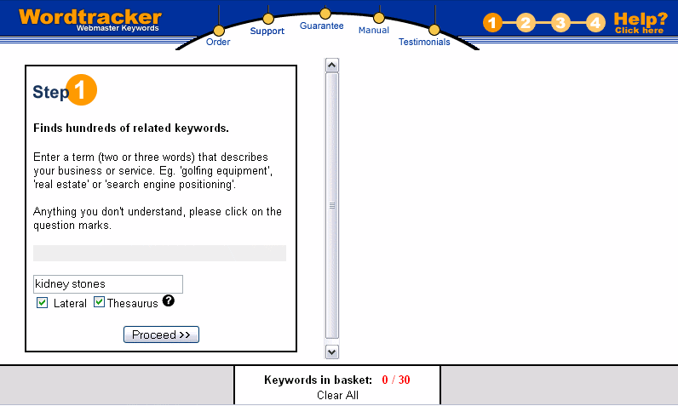

You will see the following screen while you wait:
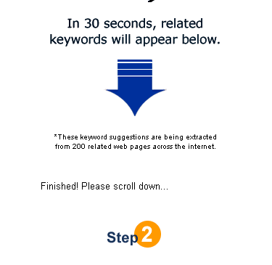
Now you come to “their” Step 2. However, before you do their next step, take a look at the related keywords and see if any of these should be added to your list. For instance, you will want both kidney stones and kidney stone, and you probably want uric acid and cystine.

Now you can click on one of the keywords. I suggest you start with the first one since it is usually more closely related.

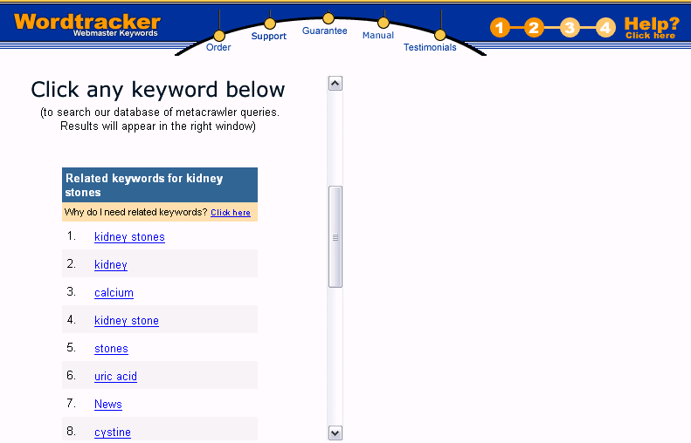

When you click on the keyword, a list of words will appear in the right hand column. If you bought a membership to this site, you would get 300 words. With the trial, you only get 15.
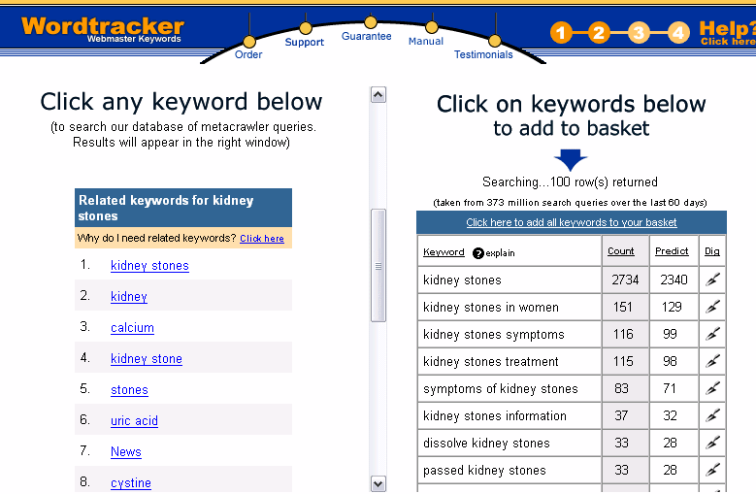

Take a look at this list and see if any of the keywords or phrases would be a good match to your topic.

Choosing a Title
Now that you have a good list of keywords, you will need to choose a title for your page. Typically, this should be short and sweet and have the main keywords. For instance, with the kidney stone example, you might want the title:

- Kidney Stones
- Dissolve Kidney Stones
- Symptoms of Kidney Stones
- Etc

The key is to choose a title that will help you optimize your blog. Don’t choose something like “Stones” because you will want to get traffic that has to do with kidney stones and not bricks!!

Creating a URL That Works
Now you want to create a URL. First, you want your URL to be keyword sensitive. Second, you want your URL to create Google Adsense Ads that match your content. Even if you are not planning to use Google AdSense, finding a URL that produces the right content will show you that your name is search engine friendly.

The way to check this is by going to http://www.resultsgenerator.com/adsense/

Place a potential URL in the field. You will want to put the entire URL into the field. This means that if you are using Blogger.com, your URL will be http://yourblog.blogspot.com
In the example, we are trying http://kidney-stones.blogspot.com.

It does not matter which variation of AdSense you choose – these are just design differences and will not create different ads.

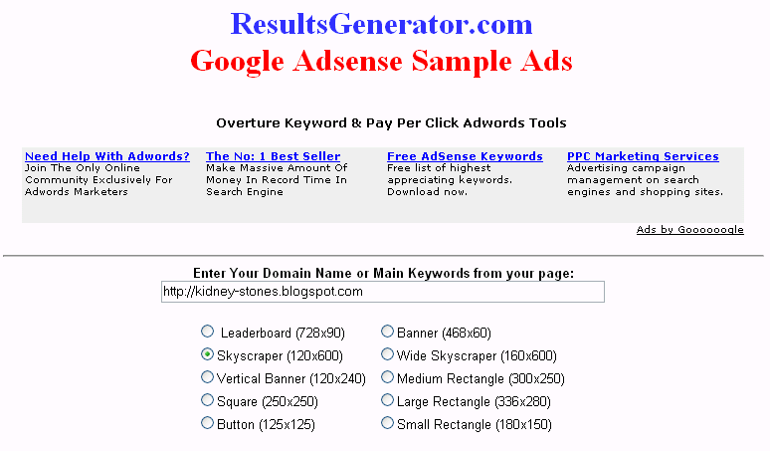

Click on “Show Me Sample Ads” and you will get a page like the following:

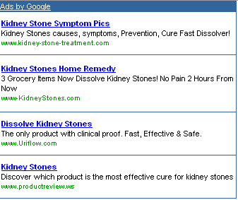

As you can see, the URL http://kidney-stones.blogspot.com does bring up related Google AdSense ads. This means that your URL is SEO friendly AND that if you choose, you can place AdSense on your blog at a future date.

Let’s look at another example. Here I am trying the URL http://commodityinvesting.blogspot.com.

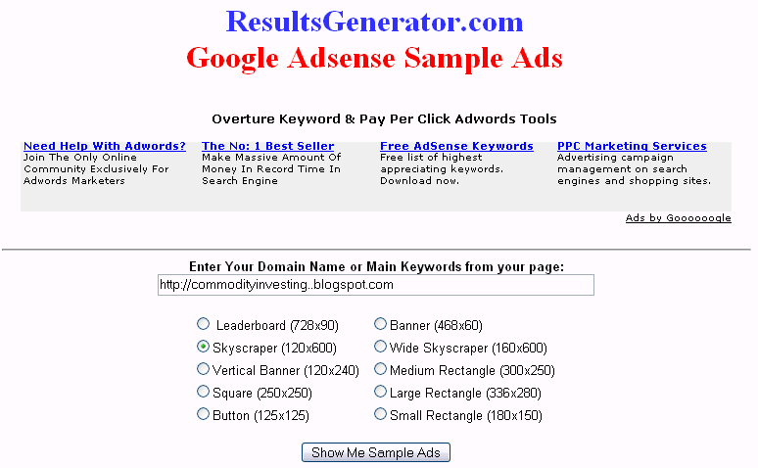

And I get the following results:
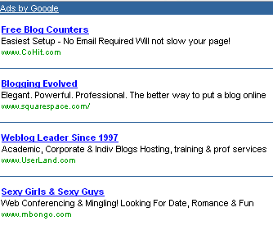

As you can see, this did not get me relevant ads at all. So I know that http://commodityinvesting.blogspot.com is not a good choice. One thing I could try would be to add a dash between commodity and investing.

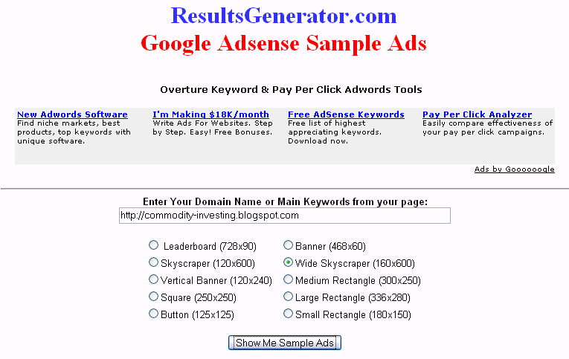
With the dash added, I got the following AdSense Ads:



Your Business Blog’s Content

The content for a blog and ping type blog is relatively unimportant. All you need are the links to the site you want to have indexed. Why? Only spiders will ever see the blog.

However, when you are creating a blog for business purposes, you need to purposefully creating blog content that has your keywords. As a Business Blogger, you can make your blog more powerful by using keywords in your content.

Using keywords in the content will ensure that search engines find your blog. And if search engines find your blog, there is a better chance that people will read what you wrote. And if you can get them reading what you wrote, then those interested in your topic are ready to be captured by your product or service.

This approach may sound like too much trouble. But consider this: if you are going to go to the effort of creating and maintaining a blog (and they are a lot of work), then why not make sure that the blog is found on the search engines via the keywords most searched by your intended audience.

You can still use BlogThis! but you will want to add some of your own content to the blog body. Let’s take a look at how to do this.

Assume that you have a business that is concerned with computer security and have a blog named Computer Security at http://computer-security.blogspot.com. As you were browsing the web, you came across the a good computer security article at http://www.pcpro.co.uk/news/65700/security-company-warning-of-vulnerabilities-in-windows-xp-sp2.html that will help you motivate people to switch over to Foxfire instead of staying with Internet Explorer.
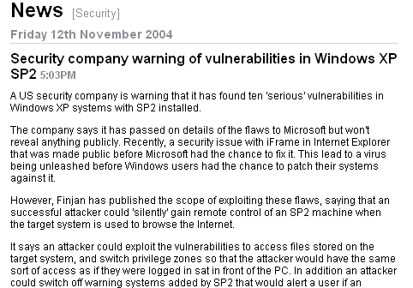

You would highlight a particular section and then use BlogThis! just like in you were taught in Chapter 5.

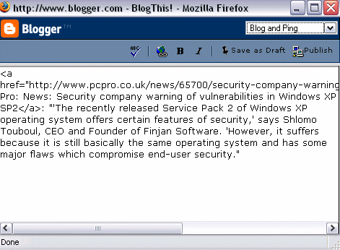

Now it is time to add your own words. In this case, I added words both before and after the quote.

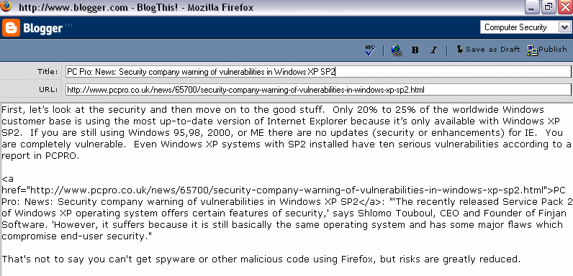

Don’t forget to click on the list to get the correct blog before publishing. The blog will post will look like this:

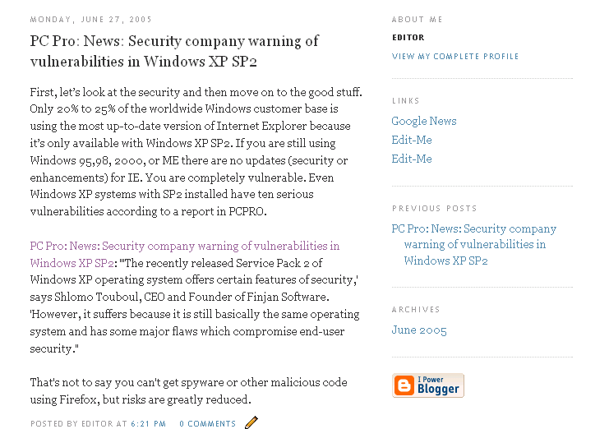

Take a look at the second paragraph. That is the BlogThis! paragraph. If you don’t like the way the paragraph starts, you can make adjustments to the HTML. The HTML in the body of the post that shows the link to PCPRO is:

<a href="http://www.pcpro.co.uk/news/65700/security-company-warning-of-vulnerabilities-in-windows-xp-sp2.html">PC Pro: News: Security company warning of vulnerabilities in Windows XP SP2</a>:
If you don’t want your sentence to start with” PC Pro: News: Security company warning of vulnerabilities in Windows XP SP2” you can change the highlighted words to something else. For instance, you might want to say “A professional in the report states”

The HTML link would look like this:

<a href="http://www.pcpro.co.uk/news/65700/security-company-warning-of-vulnerabilities-in-windows-xp-sp2.html">A professional in the report states:</a>

In this way, the finished blog entry would look like this:

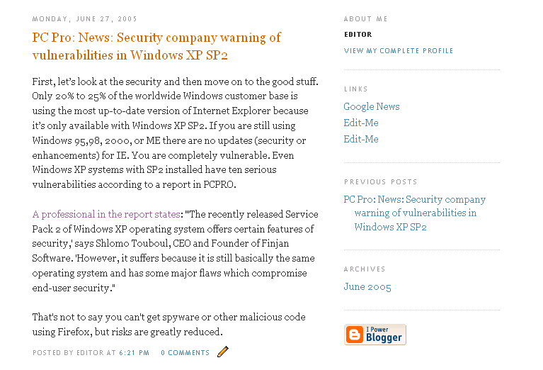

Pinging Your Business Blog

Just like with blog and ping blogs, you will want to ping your business blog. Luckily, there is no difference at all!

- You will still want to create a MyYahoo! account, register your blog, and ping Yahoo whenever you add content.
- You will still want to ping Ping-o-Matic whenever you add content.

Additionally, you may want to add your blog to several other sites for submission. The Appendix has several of these listed for your convenience.

Chapter 9: Tips and Tricks

Tips For Blog and Ping Blogs

- If you want to cut and paste into your blog content field, but the “paste” is not available, simple press Control V.

- Make a commitment to blog everyday.

- Don’t forget that the location code starts with http://api.my.yahoo.com/rss/ping?u= Mark this down. You can also store it on your clipboard for easy pasting.

- Remember that your RSS feed will end with atom.xml

- Use favorites or bookmarks. Instead of having to constantly remember the different URLs of your blogs, having to type in the ping codes, or remember the Ping-o-Matic URLs, create a folder in your favorites or bookmarks. I call my folder “Blog and Ping.” The Blog and Ping main folder has the following sub-folders:
      - Needs to be Spidered: Websites that you want to get spidered
      - Blogs: Blogs that you have created
      - Yahoo Ping: The blogs with the altered location codes so that you can ping Yahoo every time you make a change
      - Ping-O-Matic: Pingomatic sites for each blog
      - Tools: Here I would have MyYahoo to be able to view the Yahoo pings, Blogger.com to be able to make easy changes to your blogs, and the Ping-o-matic home page in case you want to add more blogs to the site.

- Do a search on your site URL at Alexa.com and see if you are found. If not, your search will have triggered what it takes to be inside their database in the near future. http://www.alexa.com/

Tips and Trick for Business Blogs

Use your primary keyword in your blog URL

Use your primary key phrase in the title of your posts.

Use your secondary keywords in the body of your post

Links pointing to your blog or posts are essential to build pagerank and make your blog rank higher in the search engine listings.
Update frequently

Once you create your blog, try to stick to the same domain and blog host or system for as long as you continue to publish. You could end up losing a lot of your traffic, your readers and all your search engine listings if you decide to move.

Before making any changes to the template, copy the original code to your clipboard. This way, if you make a mistake you can change it back easily.

Before saving template changes, click on the preview button to see if you like the changes you are making.

Changes to Your Business Blog Template

Change Editor
In the beginning, we set up your blog to say “editor” for each of your posts. In order to keyword optimize your blog, you will want to change “editor” to one of your keywords. To make these changes you have to go into the “Template” tab.

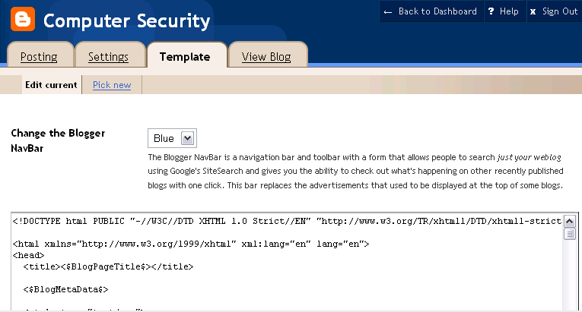

Scroll down until you find the following HTML code:
<p class="post-footer">
<em>posted by <$BlogItemAuthorNickname$> at <a ref="<$BlogItemPermalinkUrl$>" title="permanent link"><$BlogItemDateTime$></a></em>

Change the highlighted code to a name with one of your keywords, for instance, Computer Security Guru. The new code would look like this:

<p class="post-footer">
<em>posted by <$BlogItemAuthorNickname$> at <a ref="Computer Security Guru" title="permanent link"><$BlogItemDateTime$></a></em>

Save the Template changes and then republish. You will need to do this for each blog that you create.

Adding Links
The more links you have on your blog, the better. You can add pertinent links in the sidebar. Once again, go to the “Template” tab and scroll down until you see the following code:

<h2 class="sidebar-title">Links</h2>
<ul>
<li><a href="http://news.google.com/">Google News</a></li>
<li><a href="http://EDITME">Edit-Me</a></li>
<li><a href="http://EDITME">Edit-Me</a></li>
</ul>

This is the HTML code for the sidebar links. The yellow shaded code is the URL for the link. The green shaded code is what the person sees when visiting your blog. You will want the green code to be full of keywords.

For instance, if you are working with your Computer Security blog, you may want to link to http://www.cert.org/homeusers/HomeComputerSecurity/. To do this, you would change one of the yellow highlighted fields to http://www.cert.org/homeusers/HomeComputerSecurity/ and then you would change the corresponding green field to something like Home Computer Security or any other combination of keywords.

The final code would be:

<li><a href=" http://www.cert.org/homeusers/HomeComputerSecurity/">Home Computer Security </a></li>

You can create as many links as you like using this method. Once you are done creating links, be sure to save your changes and republish your blog.

The finished product would look like this:

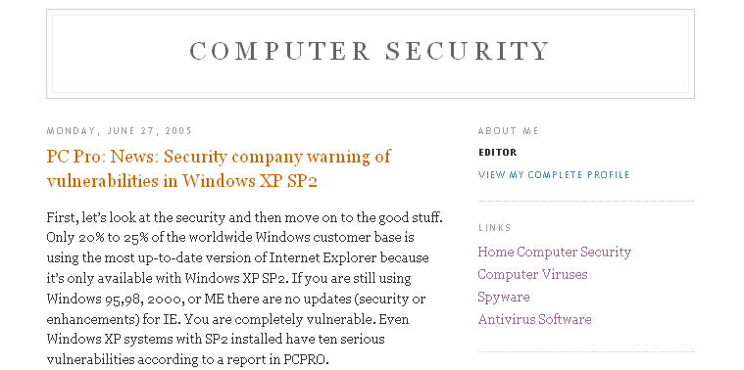

Change About Me
Looking at the sample above, you will see an “About Me” section in the right hand sidebar. You will want to change the “Editor” in the sidebar to reflect the same name that you use when posting. Go to the “Template” tab and scroll down until you find the following code:

<!-- Begin #profile-container -->
<$BlogMemberProfile$>
<!-- End #profile -->

Change the highlighted code to your posting name. In the case of this blog, it is Computer Security Guru.

<!-- Begin #profile-container -->
Computer Security Guru
<!-- End #profile -->

Save the template changes and republish.

Changes to Your Business Blog Settings

All the settings for a business blog are identical to the settings for a blog and ping blog. However, you can add a description to your Business Blog that will help it be search engine optimized.

Go to the Settings Tab and then click on the sub-tab called Basic. Put in a description that uses your keywords. Then click on Save Settings and then on republish.

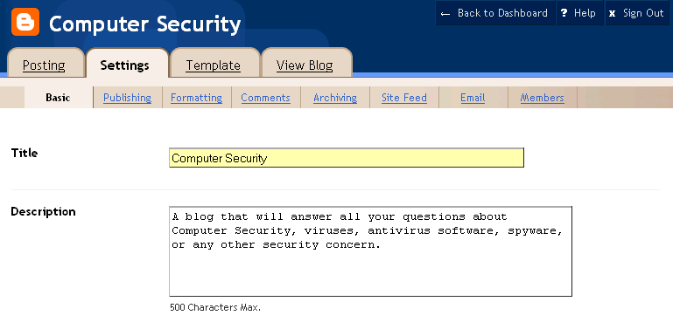

Conclusion
There you have it. You now understand blogging and pinging and have all the secrets and tips that will make this work for you. Instead of waiting weeks, months, or even up to a year, you can get your website or your business blog indexed almost immediately.

Blogging and pinging is certainly an incredible marketing tool.

Appendix 1 - Blogging Submission Sites

Blogging With Dr P...
w3matic's Traffic & Viral
Stephen Downes Blog site
Kmax
Libdex
Diarist
The Pepys Project
Crayon
Kiosken
Headlinespot
Rocketinfo
Scripting.com
Blog Matcher
Blizg
Blogz
Bloogz
Eatonweb
Blog Search Engine
Fastbuzz
Contentsmatter
Blogarama
Memigo
Truth Laid Bear
Blog Universe
Blogtree
Open Weblog Directory
GlobeofBlogs
2RSS
BoingBoing
Blogwise
Blog Critics .org
Popdex
Topix
Blogdex
DayPop
Genecast News Service
Guardian WebLog Guide
YellowBrix
Newsknowledge
NewsIsFree
Open Directory
rssxpress
PheedCentral
Bloglines

Appendix 2 – Weblog Providers
There are many other weblog providers besides Blogger.com. Here are just a few:
DeadJournal
This is a blogging provider for individuals who wish to belong to a community of bloggers with an "edge."

LiveJournal
This popular free blog host is preferred by many individuals who enjoy a community-based blogging system. It is web-based and the sign-up process is quick and easy. There's also a premium version.

Movable Type
This is a popular blog software among bloggers who like to manipulate web designs, formats, and functions. However, you need to have some programming skills (or pay for an installation service) and your own web host. While there is a free version, some bloggers might find the licensing agreement on this too limiting. For more flexibility, there are several licensing fee options for both personal and commercial users.

WordPress
This free blog software is b2/cafelog's official successor. It has a great interface and useful features like 'private' posting (password-protected), file uploads, and more. You need PHP version 4.1 or greater, MySQL version 3.23.23 or greater, and The Apache mod_rewrite module (optional, for the nice URI functions) on your server.

21Publish
21Publish is a new paid blog service that is geared towards "cooperative publishing" (mainly for groups). It allows organizations to build their own blog portals. The fees vary, depending on the number of bloggers, expected usage, etc.

b2
A sleek and highly underrated weblog publishing tool. You need PHP4 (version 4.0.5 or higher), MySQL (version 3.23.23 or higher), and Perl (optional) to run this program on your server. This is a free blogging platform.

Blog Drive
This free blog host with a clean interface supports multiple blogs and authors, as well as built-in features like a tag board, commenting system, email notification, calendar, and archives. You just need to display a banner on your blog.

Blog Easy
Here's a simple blogging host with free and premium services available. The account has basic features like comments and archives. There are limited customizable features.

Blog-City
Basic blog features are available in the free version, like comments, archives and online administration. Blogs expire after a certain time if they're not used. The advertisement-free premium service contains more advanced features like RSS feeds, photo albums, BlogBoards, search, and more.

Blosxom
Blosxom (pronounced "blossom") is an open source web logging platform that runs on Perl. This is best for bloggers who seek a simple, 'minimalist' blogging software.

Bravenet Journal
One of the latest offerings of Bravenet, a web services company, is this blogging system. You just need to sign-up to start your own blog. There are some built-in functions like comments, mood indicator and a tag board. The free version contains seveal ads for Bravenet. To remove the ads, you need to pay a subscription fee.

Diaryland
The latest version of Diaryland offers two ways to share posts and stories: a one-entry-per-page view (original diary-type posts) and multiple-entries-per-page view (blog-type posts). This site is primarily for personal users.

Geeklog
It's a weblog platform that uses PHP4 and MySQL. Some of its features include messaging, comments, polls, and calendar, among others.

JournalSpace
Simple, feature-filled weblog hosting provider. It has moblogging, photo blogging, site feeds, audio blogging and other functions. It's free!

ModBlog
A free blogging software that caters to novices and advanced users alike. There are several features available including customization, built-in chatterbox, bulletin, profile, playlists, backups and a free 1 MB image storage. Users can pay fees for additional features (ads removal, more image storage space, etc.).

Simple PHP Blog
A stand-alone weblog platform that needs PHP 4 or greater.

SquareSpace
Sleek, powerful hosted weblog system. There's a free package, but more features are available for those who purchase either a personal or business license.

tBlog
A free blog tool with free blog templates and hosting. Just sign-up, design your theme, and start blogging. You can customize the look and feel of your site. And, unlike many free blog platforms/hosts, this one does not force you to display a banner on your blog.

Text Pattern
It is a simple content management system that can be used for web logs. It has a clean interface. It's donateware.

UpSaid
This host offers a free and premium service. The free service offers basic features like templates, counters, polls, and a guestbook. It has a clean, smooth look that can be easily customized.

UserLand Software
This is a Personal and Business web logging tool. Manila software is for business enterprises and Radio UserLand is for personal publishing. There are free trial copies available on the site. Both are available for a fee after the trial version expire.

Appendix 3 – Photo Blog Software
Hello BloggerBot
This is an enhancement photo blogging and peer-to-peer sharing software from Picasa. It works with a Blogger.com weblog.

SnapLog Photo Blog
SnapLog Photo Blog is BETA software. A description of this tool from the site is as follows: SnapLog is a Windows XP/2000/98 application that provides an easy interface to share photos on your website.

Zorpia
This is an online social networking site with blogging and photo blogging features.

"Learn how to make a life-changing income of $100,000 to $250,000 with your Internet business... even if you're a computer dummy!"
Review: "The Insider Secrets to Marketing Your Business on the Internet" by Corey Rudl
I've just finished reading the brand-new 2005 version of Corey Rudl's top-selling Internet marketing system, "The Insider Secrets To Marketing Your Business On The Internet," and frankly, I'm overwhelmed by the huge amount of critical wealth-building information he's managed to pack into these two hefty binders and 3 CDs!
But I guess I shouldn't be surprised; after all, when the box containing these materials showed up at my door, it weighed in at over 10 pounds!
That's 10 pounds of the most comprehensive marketing strategies, test results, case studies, tools, and ideas for generating a life-changing income online (from $1,000s to over $1 million) you're ever likely to read!
Click here for a FREE preview.
I'm talking about information like...
- Step-by-step advice for starting your own Internet business in as little as 48 hours!
- How to build a top-selling web site... for less than $100!
- Where to find hot products to sell (in 20 minutes or LESS)!
- 100s of FREE and cheap online tools, resources, and software
- How to get 1,000s of qualified NEW visitors to your web site... for FREE!
- How to get #1 rankings in the search engines and get tons of FREE traffic from the "Big Guys" like Google!
- Secrets to writing sales copy that can increase sales by up to 400% (or MORE)! And much more!
If you're unsure who Corey is, you should know that he's been a recognized expert in online marketing for a decade now. Not only has he generated $40,000,000 in online sales, his sites also attract 450,000 visitor a week!
What's really great about Corey is that he can show ANYONE how to have a wildly profitable Internet business (that takes just a few hours each day to run)...
... even if you're an absolute computer dummy!
And if you already have an Internet business, he can help YOU, too. The advanced sections of his system show you how you can increase your sales by 400%... 700%... even as much as 1,000%!
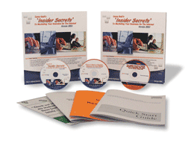
I give Corey's system the highest rating possible! Its 1,300+ pages of step-by-step lessons contain the exact SAME tested and proven fast-growth strategies he has personally used to generate over $40 million in online sales -- starting on a shoestring budget!
And it's the SAME SYSTEM that literally 1,000s of his students have used to drive "truckloads" of cash out of the Internet.
I strongly urge you to check out Corey's wealth-building system as soon as possible!
Click here for a FREE preview.

